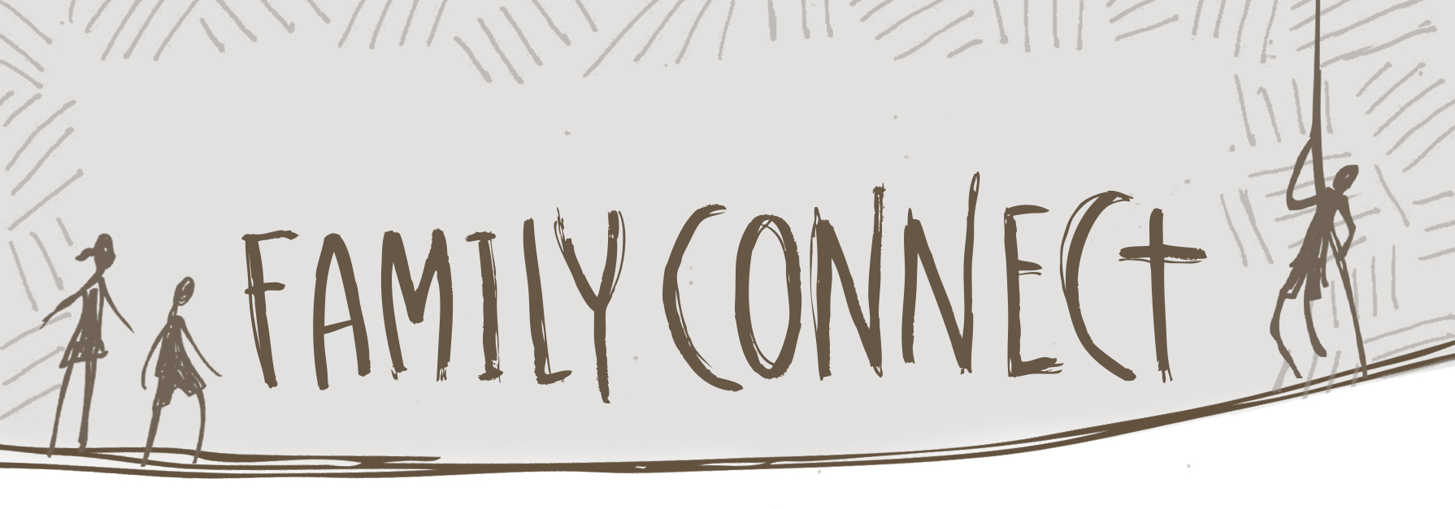

The Need for a Rescuer
Session 1

Bible Story Tales of the Ones He Won’t Let Go Story
Jesus Calms the Storm (Luke 8:22-25) “Forever Family”

Bible Memory
Hebrews 10:23, 24

This series of lessons will hopefully spark an interest in your child to consider God as their Rescuer, someone who keeps holding onto them, no matter what life brings. Your child will come to understand that our Storyweaver God sees the complete story and is always coming to rescue him. Your child will wonder about a world bigger than the community he is a part of and become curious how he can connect with that world. Your family can begin to have conversations about who you trust, how you can pray, what you can give, where you can go, who you can serve, and how you can love your neighbors.

If your family has 15 minutes this week
Take a minute and write down three times you have felt God’s hand holding onto your family. Talk about travel, sickness, big games, new siblings, provision, protection, and so forth. Share your lists with each other.

If your family has 30 minutes this week
Talk about hard stories. When does it seem like God let go of your family, or one of its members? If we know that’s not possible, then how can we see and talk about hard stories from this perspective? How could God be holding on, even if the story isn’t turning out the way we wanted?

If your family has 60 minutes this week
Go online to find and print out a world map. Locate the countries of Mexico, China, USA, Haiti, and Nigeria. Look up some general information about each country. You could also find out if your church sponsors any missionaries serving in those countries. Using colorful paper, design a place mat for each country. Include a map, some interesting facts, and anything else that will help your family remember to pray for God’s work that’s happening in each of those countries. Cover the mats with clear contact paper and use them for your family meals. Each night at dinner, pray for a different country.

