Conversation Cards
Session 1

Cut apart the following cards. Put the first one on your refrigerator, the second one in your car, and the third one in your work area. Let the conversations begin!
------------------------------------------------------------------------------------------------------------
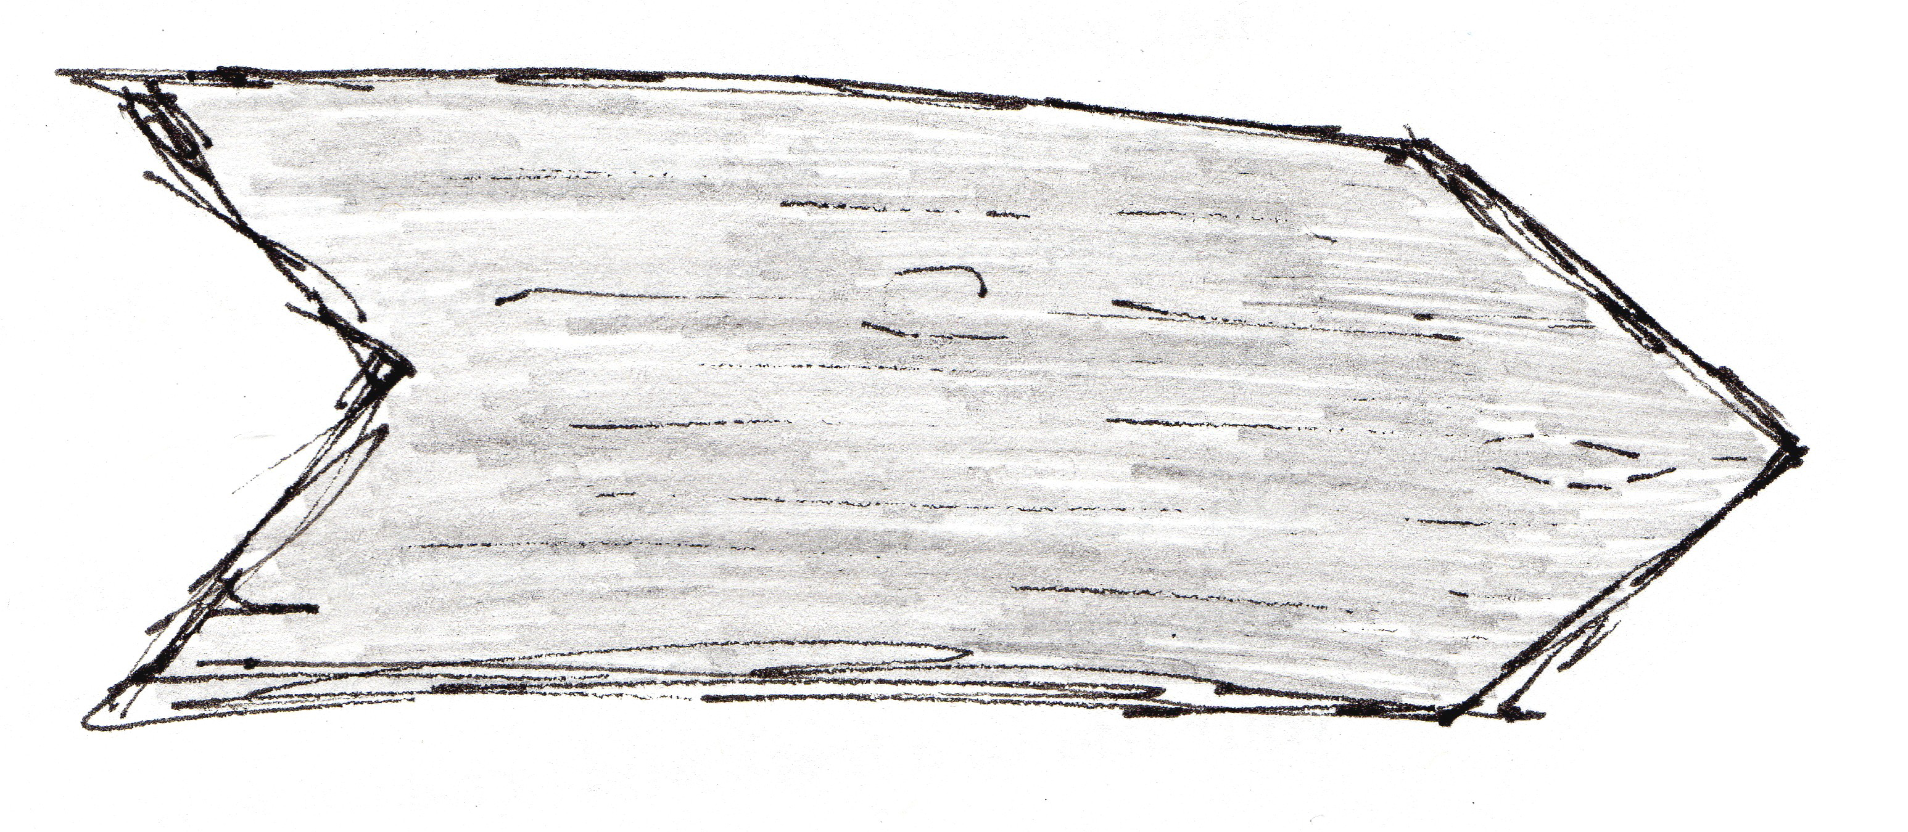
You’re going to be learning about kids in hard situations and how God won’t ever let them (or you!) go. In what situations in particular can you imagine a child in poverty needing God’s hand?

------------------------------------------------------------------------------------------------------------
• When do you feel afraid?
• What comforts you?

------------------------------------------------------------------------------------------------------------

• Do you know missionaries you can pray for? Where are they?
• What prayer needs do you think they have?

------------------------------------------------------------------------------------------------------------

